УДК 502 : 58

LAND COVER FEATURES OF THE POOL OF RIVER POLIA OF THE EASTERN SLOPE OF THE SUBPOLAR URAL

Bolshanik P.V.¹, Kusnezova S.B.¹

¹⁾ Yugra State University, Federal State Budgetary Educational Institution of Higher Education

bolschpetr@mail.ru

Summary. The article discusses the natural conditions, landscape, floristic and phytocenotic features of the territory of the Polia River Basin, located on the eastern macro slope of the Subpolar Urals. A historical overview of geographical studies of the area is given. The main components that affect the formation of the landscape structure of the study area are characterized. A landscape map of the studied region is proposed, on which 19 types of geosystems are distinguished. Particular attention is paid to the characterization of rare plants (Rhodiola rosea L., Veronica spicata L., Trollius apertus Perf. ex Igoschina, Acomastylis glacialis (Adams) A. Khokhr., Triglochin palustre L., Pentaphylloides fruticosa) listed in the regional Red Book. The necessity of isolating the study area as a specially protected natural area is substantiated.

Keywords. . Phytocenotic diversity, landscapes, rare and protective plants, specially protected natural areas, anthropogenic transformation of vegetation cover.

INTRODUCTION

In June-July 2019, students and professors of Yugra State University conducted an expedition in northwest part of Berezovsky district of Khanty-Mansy autonomous district – Yugra. This territory is very poorly explored. There is some information about neighboring river valleys.

According to the Environmental doctrine of the Russian Federation [14] the preservation and development of specially protected natural territories of different levels and regimes is one of the priorities of the state environmental policy in order to ensure environmental safety and preserve the national natural heritage of the peoples of Russia. The concept of long-term socio-economic development of the Russian Federation until 2020, approved by Decree of the Government of the Russian Federation dated on November 17, 2008, N 1662-R, it was found that the creation of a system of specially protected natural territories for the conservation of natural ecosystems in all climatic regions of the country, is one of the main areas of ensuring environmental safety of economic development and improve the ecological environment of human life.

In Russia, the creation of specially protected natural territories is the traditional and most effective form of environmental protection. The specially protected natural territories are designed to preserve typical and unique natural complexes and landscapes, the biological diversity of the animal and plant world, and the protection of natural and cultural heritage.

A high level of anthropogenic and technogenic impact on the environment, low indicators of environmental sustainability, as well as intensive development of processes of degradation of natural ecological systems characterize the environmental situation in Yugra, the main oil-producing region of Russia.

In case of implementation of the Concept of development and functioning of specially protected natural territories of Khanty-Mansy autonomous district - Yugra for the period up to 2030 [12], there are plans to ensure the development of specially protected natural territories of autonomous district to the level necessary to fully carry out its objectives; sustainable functioning of the system of specially protected natural territories, consistent with the principles of environmental safety; effective management of the specially protected natural territories system; introduction of the system of especially protected natural territories in the socio-economic development of the region as an independent environmental and economic management object in the system of sustainable existence and rational nature management.

The total area of specially protected natural territories in the autonomous district is 2592570.1 ha (4.8% of the area of the autonomous district).

The main goal of the study was to find prospective territories for the allocation of new specially protected natural territories, conduct an analysis of phytocenotic diversity, and identify features of the landscape structure of the Polia River basin.

The main objectives of the study were to describe the physical and geographical conditions of the interfluvial areas and valley of the Polia River, to study the experience of previous expeditions, to identify rare and endangered plant species, and to characterize their habitats.

Materials and methods.

The research area (Fig. 1) is located in the vast interfluve area of the Manya and Shchekurya Rivers, to the South and Southeast of the Dyavolaiz range, in the valley and in the watershed around the Polia River, which is a left tributary of the Shchekurya River. The territory was poorly affected by anthropogenic factors, so there are preserved landscapes that reflect the virgin natural structure of geosystems. The only man-made structure is a paved road that runs along the route from Saranpaul village to the upper reaches of the Shchekurya River and lies to the North of the research area.

To achieve these goals, a number of field works were performed such as: a description of the floral richness of the region, geobotanical and geomorphological profiles were laid in key areas, description of typical landscapes, and landscape mapping (Fig. 2). Geobotanical and geomorphological profiles were drawn along the same line (coordinates of the starting point of movement – 64⁰23' North latitude and 60⁰30' East longitude) and were laid on five sites: 1) in the area of wedging out of the left-bank terrace and replace it with a rock ledge on left bankof the Polia River , after the merger of the Small and Great Polia River, with a length of one km (coordinates of the end point of the movement – 64⁰22' North latitude and 60⁰31' East longitude); 2) in the floodplain and on the terrace of the right bank of the Great Polia River upstream, and of a hill with a height 269,8 m, a length of about 22 km (coordinates of the end point of the movement – 64⁰ 26' North latitude and 60⁰26' East longitude); 3) in the floodplain and on the terrace of the left bank of the Small Polia River upstream, with a length of about 12 km (coordinates of the end point of the movement – – 64⁰24' North latitude and 60⁰25' East longitude); 4) near the right bank of the Polia River and hill height 239,1 m, a length of about 6 km (coordinates of the end point of the movement – 64⁰20' North longitude and 60⁰33' East latitude); 5) near the left bank of the Small Polia River and the right bank of the Poliatally River, a length of about 12 km (coordinates of the end point of the movement – 64⁰21' North latitude and 60⁰27' East longitude). In all studied sites was carried out a comprehensive description of landscapes, which included characteristics of the vegetation cover, the soil description section, description of terrain.

Geobotanical descriptions were performed using generally accepted methods [8, 13, 15]. When specifying Latin names, the system of S. K. Cherepanov was used [17]. Only vascular plants were collected and herbalized. The herbarium is kept at Yugra State University.

The studies of the research area.
The first information about the nature of the region was obtained mainly due to the expedition of the Russian Geographical Society, which was in 1847. E. Hoffman, moving from Koshem on Polia road, explored the territory leading to the Shchokuryinsky pass and came to the village of Saranpaul.

In 1886, merchant Sibiryakov built a new road through the Ural range instead of the difficult and long road along the Shchokuryinsky pass, in the South-West direction from the village of the Shchokuryinsky, near the mountains of the Peti and Telpos [11]. The builder, and later his deputies, used this road for a long time to transport cheap Siberian bread to Pechora. Currently, the road serves only the needs of the local population.

In 1900 and 1901, the North Ural Mining company was prospecting for gold in the lower reaches of the right tributaries of the Lyapin River. Steiger Ponomarev, the manufacturer of these works, made an eye survey of the Lyapin River and its mountain tributaries from the top to Saranpaul.

In 1915, B. N. Gorodkov made a trip in a boat along the Manya River to its upper reaches near mountain of Salner, and then on a horse along the Sibiryakovskaya road to the Volokovka River. He described the terrain and flora of the territory [5].

In 1926-28 The North Ural Expedition explored the territory bounded on the North and South by 67° and 65°10 ' North latitude, on the West by the watershed of the Pechora and the Ob Rivers and the Ob River-on the East. The main attention is paid to the Ural range, which is divided by rivers belonging to the Sobi, Voykara and Syni systems. The research was carried out: soil-botanical with the participation of a post-graduate student of the Botanical Museum of the Academy of Sciences V. B. Sochava; zoological – K. K. Flerov, a post-graduate student of the Zoological Museum of the Academy of Sciences, and his assistant collector E. A. Sludsky; geological research was entrusted to a post-graduate student of the Leningrad State University, A. N. Aleshkov, who simultaneously served as the head of the expedition. S. A. Yanchenko, a student geodesist at Leningrad State University, was invited to perform topographical work [1]. The research papers of the North Ural Expedition made it possible to make a comprehensive description of the studied territory. The research of the North Ural expedition significantly supplemented the list of plants of the circumpolar Urals, mainly with more southern forms, the Northern border of which runs in the Urals within Lyapin basin. In addition, as a result of the survey of the sources of the Kozhima River (Kozhimskaya depression), there are some Arctic plants that have not yet been found even in the more Northern regions of the Urals (Gentiana chrysoneura Eust. et Murb., Cassiopeia tetragona (L.) D. Don.). The proximity of the flora of the Northern Urals to the Central Siberian flora has been further confirmed in some new finds of Eastern plants, of which the gentian prostrate (Gentiana prostrata H a e n k e) is particularly noteworthy.

In the period from 1948 to 1963, P. L. Gorchakovsky studied the plant world in the Subpolar Urals. In his works [6] he describes the territory located to the West of the studied area.

In June-July 2019, professors and students participated in an expedition as part of the RGS grant project: "Along the routes of the first explorers of the Subpolar Urals (dedicated to the 115th anniversary Of S. G. Bocha's birth)". Members of the expedition conducted geological, geomorphological, geobotanical and landscape studies.

CHARACTERISTICS OF THE NATURAL CONDITIONS OF THE TERRITORY UNDERSTUDY

Terrain.

From the East, the Urals are bordered by a strip of rocky terrain. In turn, rolling the band a few raised above the level of the West Siberian plain.

The area of the reduced island mountains of the Eastern slope belongs to an independent geomorphological unit corresponding to the hypsometric stage of 200-500 m. Low-contrast terrain with the development of soft-edged characterizes it, gently sloping mountains, sometimes isolated, often connected by wide saddles. Interstitial spaces often represent vast and flat areas that are heavily waterlogged and almost completely unaffected by modern erosion, located at various hypsometric levels. The border of this area is everywhere set relatively easily and is characterized by an increase in absolute marks and an increase in sharpness of forms. Most likely, we should assume that in this case we are dealing with an erosional terrain, subsequently subjected to marine abrasion, and then modeled by glaciers. This assumption is confirmed by the presence of wide depressions, possibly representing sea bays, partially made by marine deposits, forming a skerries-type coast. In this case, the sharp western border observed in some areas has an abrasive origin [3, p.33-36].

The terrain of the study area is a hilly plain, divided by the Polia River and its tributaries. The minimum mark at the edge of the Polia River is 80 meters. The maximum height is 269.8 m. All the hilltops are wooded. On the gentle slopes of hills, where water flow is slowed down, upper swamps are formed. They are mostly large-banded with thickets of dwarf birch, sphagnum moss, ledum and sometimes cloudberry and cotton grass.

The rocky strip of the Eastern slope was described by E. S. Fedorov and P. P. Ivanov [16] and V. A. Varsonofieva [4]. It is characterized by a gently undulating terrain that declines to the East and strong waterlogged watersheds.

Climate.
According to climate zoning [3, p. 50], the research territory belongs to the trans-Ural climate region with cold winters and cool and humid summers. In winter, snowstorms are frequent; there are spring and autumn ice, frosts, and fogs. The shortest frost-free period on the territory of Yugra (80 days or less). Summer is cool and humid.

Main climatic indicators are shown on table 1.

Hydrography.
The river valleys of the main rivers cut into its surface, forming deep valleys that, when leaving the limits of large ridges, as well as in the area of distribution of middle Paleozoic rocks, acquire a canyon-like character, which indicates the young uplifts that this area is experiencing.

Polia River flows through the territory of the Berezovsky district of Khanty-Mansi autonomous district-Yugra. The mouth of the river is located 7 km along the left bank of the Shchekurya River. The river is 34 km long [7]. The length of Great Polia River is 37 km. The length of the Small Polia River is 16 km. The Polia River is formed from the confluence of the left tributary the Great Polia and the right of the Small Polia River, which in turn has a tributary of the Poliatally River. Other tributaries and streams in the study area do not have proper names. The Great Polia River is about 20 meters wide, with an average depth of about 0.6 meters and a hard rocky bottom covered with large pebbles and boulders with a silty coating.

The Small Polia River has an average width of about 10 m, a depth of about 0.4 m and a hard rocky bottom of pebbles and boulders. The average speed of the current in the period between floods was about 0.7 m per second. The absolute height of the confluence of the two rivers is about 102 m. The estuary of the Poliatally River is greatly expanded and not deep, which is explained by the water retention of the main river. The river regime in July has a flood character. The rise of water in rivers, after rains reaches a meter height. The Polia River valley has a canyon-like character. The floodplain is narrow and segmented. The terrace is above floodplain is not always expressed and presented in fragments.

River nutrition is mixed with the predominance of snow. Spring floods and high water floods characterize the regime in the warm time of the year [3, p. 61-76].

As rivers leave, the high-altitude zone and enter the mid-mountain zone (800-500 m), their valleys widen and their slopes become flat. There is a fragmentary floodplain and, accordingly, floodplain vegetation. Although the rivers retain their mountainous character, the current here is slow. The riverbeds are often divided into branches, forming low islands covered with birch-larch forest and shingle shallows.

When crossing rivers ridge strip their valleys narrow, sometimes turning in a canyon-like gorge, embedded in 80-100 m. The drop increases sharply (up to 5 m / km). After entering the Lyapin depression, the valleys expand, forming a wide floodplain with moisture-loving vegetation.

Soils.

According to soil-ecological zoning [3, p. 82], the research territory is included in the Ural mountain province of poorly developed gravelly soils, podzols of illuvial-ferruginous and podbur and glee-podzolic soils.

The vertical zoning structure of this province begins with glee-podzolic soils in the lower parts of the slopes of the terraces, and then there are podzols of the lower belt and end with poorly developed gravelly soils and stony placers on the surface of the hills.

RESULTS

Vegetation
According to geobotanical zoning [3], the studied territory belongs to the Ural-West Siberian taiga province of the Eurasian taiga region and is located in the Northern taiga subzone. The Northern taiga subzone is dominated by larch, spruce, pine, cedar and birch forests. Their ground cover is dominated by lichens (Cladonia alpestris (L.) (Opiz) Pouzaret Vezda., C. rangiferina (L.) F. H. Wigg, Cladonia silvatica (L.) Hoffm) and mosses (Pleurozium schreberi (Brid.) Mitt., Hylocomium splendens (Hedw.) Bruch et al., species of the genus Sphagnum). The growth of moss cover contributes to waterlogging of forests, which are often combined with permafrost swamps. The flora of grasses and shrubs is not numerous. Widely represented are the Hypo-Arctic shrubs-Ledum (Ledum palustre L.), blueberries (Vaccinium uliginosum L.), cranberries (Vaccinium vitis-idaea L.), blueberries (Vaccinium myrtillus L.), black crowberry (Empetrum nigrum L.) [3]. Since the absolute heights of the research territory are not large, only the boreal belt class is allocated here [3, p. 83].

Preliminary analysis of cartographic sources [2, p. 4] allows you to create a draft map of forests (by prevailing species). The areas highlighted on this map then served as the basis for creating a vegetation map and later a landscape map. However, field research allowed us to refine the map of forests [2, p. 4], the coincidence with which was only 10%.

The territory of the steep strip of the Eastern slope is covered with dense forests of spruce, larch, cedar and pine. The higher up the Eastern slope in the mountains, the more larch in the taiga, and the upper border of the forest is almost exclusively larch with juniper and polar birch in the shrub layer.

Botanical research was carried out mainly in the geobotanical direction (table 2).
As a result of geobotanical work, it turned out that the mountainous part of the research area can be divided into two strips: 1) a strip of coniferous forest with a predominance of spruce and with a wide participation of Siberian and common pine, birch and fir; occupying the foothills and the base of the slopes of the main ridge;
2) a strip of coniferous forest consisting of larch and cedar with an admixture of birch and pine, forming the upper scope of the forest vegetation and not reaching a significant height.

P. L. Gorchakovsky [6] proposed similar division in his paper, but in a more generalized version: bald bald larch woodlands and mountain spruce forests.

The foothills, which belong to a strip of coniferous forests with a predominance of spruce, are almost completely forested. The most common formation of this strip is spruce with an admixture of cedar and birch. Relatively rarely and in small areas in these forests is dominated by fir. Fir trees are usually confined to rich soils with a large amount of organic matter. In places where the ground is shallow and the bedrock is close to the surface of the day, in the forests dominated by other species of cedar. The smallest area within this strip is occupied by absolutely treeless or with cedar and pine swamps.

The strip of larch forest, despite its small area, is represented by a variety of communities. In addition to larch trees, there are also birch trees in this zone.

Six rare plants were found on the research territory (table.3), listed in the Red Book of Yugra [9].

In addition to these species, there were found species that were previously included in the list of rare plants of Yugra - [10] such as Actaea spicata L. (Fig. 3), Pediculáris verticilláta (Fig.4).

Along the banks of streams, in wet and swampy places in this strip, there are thickets of willows: tea leaved willow (Salix phylicifolia L.), shaggy (S. lanata L.), glaucous willow (S. glauca L.) etc. On flat passes, in wet places-Arctic shrub, dryad incised (Dryas octopetala L. subs. subincisa Jartsev) and herbaceous plants novosieversia glacialis (Novosieversia glacialis (Adams ex Fisch.) F. Bolle), Ranunculus frigidus W., single-color sedge (Carex rigida Good.) etc.

Under the condition of stagnation of moisture, swampy mountain tundras develop with Scheuchzer's cotton grass (Eriophorum scheuchzeri Hoppe), multi-columnar cotton grass (E. polystachyon L.), chestnut bulrush (Juncus castaneus Smith.), and rare-flowered sedge (Carex rariflora (Wahlenb) Smith. etc

In drier open areas, there are spotted mountain tundras with a variety of vegetation. In the ground cover here, in addition to mosses, lichens are found in large numbers. Of the lichens, the most common are: Cladonia silvatica (L.) Hoffm., C. uncialis (L.) Weber ex F. H. Wigg., C. amaurocruea (Floerk.) Schaer., Alectoria ochroleuca (Hoffm.) A. Massal. and Sphaerophorus globosus (Hud.) Vain.

In areas of stony placers, almost no vegetation is found, with the exception of scale lichens, of which Rhizocarpon geographicum (L.) DC is particularly characteristic. This lichen sometimes gives a greenish color to entire stony slopes. Among these stony fields there are areas covered with a powerful carpet of reindeer moss, mainly Cladonia alpestris (L.) (Opiz) Pouzaret Vezda. and partly C. rangiferina (L.) F. H. Wigg. Of the flowers here, the most common is ledum (Ledum palustre L.), in addition, you can find cranberries (Vaccinium vitis-idaea L.), (Hierochloe alpina (Sw.) Roem. et Sshult) and very rarely others. Sometimes rocky placers are interrupted by moss communities. Their very poor flora is still richer than lichens.

Stone deposits are not associated only with the bald deserts zone cold zone. They are also found in mountain belts on steep slopes.

Quite special is the vegetation of river valleys, which, although also subject to the rule of vertical zoning, but the alternation and character of vegetation strips there are special.

Human influence on vegetation is weak, with the exception of places close to the Sibiryakovsky tract and Polinskaya road. Here you can see the transformation of vegetation caused by logging and fires. A field camp of gold miners was found. Although the territory of the camp was well-equipped, after leaving it, the grass cover was quickly restored and only the abandoned structures and products indicate the presence of people. Successional changes of vegetation occur exclusively through birch.

Landscapes.
Landscape profiling and a comprehensive description of geosystems during the expedition allowed us to classify the selected types of landscapes (legend Fig.2) and create a landscape scheme (Fig. 2) of the research territory.

When classifying landscapes, we used evolutionary-dynamic, structural-dynamic and morphological approaches. The natural relationship between the topography, parent rocks, drainage conditions and typical locations is taken into account, considering the history of the territory's development.

Due to the excessive wetness of the territory, the wide development of hydromorphic landscapes, all types of lowland complexes are grouped into two main series, which differ in the manifestation of latitudinal zoning, the direction of development processes and environmental characteristics.

The taiga belt of low-mountain landscapes extends from riverbeds to altitudes of 300 m and is formed by spruce with an admixture of cedar and birch, cedar with an admixture of larch, birch and spruce, and less often pine lichen and green moss-shrub-lichen woods.

Intermountain longitudinal depressions in the upper reaches of rivers are occupied by permafrost sphagnum swamps, sometimes with rare depressed spruce or pine.

Floodplains and valleys of streams and small rivers represent mountain-valley complexes. Along the depressions and valleys of the streams, there is a dense shrub with moss-lichen cover, interspersed with small sedge-sphagnum swamps. Among the floodplain forests, mainly spruce with an admixture of birch, there are meadow glades of taiga high grass, along the riverbeds stretch stony beaches.

Conclusion.
As a result of the expedition, differences in the diversity of vegetation cover in the valleys of the Polia River and its tributaries were identified. In the floodplain and adjacent slopes of the Polia River and Great Polia River had a greater variety of plants, unlike the floodplains and slopes of the Small Polia River and Poliatally. This is probably due to the wider Polia River floodplain and the meridional migration of animals and birds, and consequently the spread of plant seeds along the valley.

Field research has allowed us to clarify the boundaries of plant communities and the species composition of forests, which differs from the materials of previous studies. Matches with cartographic sources described in the Atlas [2] is about 20 %. The territory is dominated by coniferous forests of mixed species composition. It is quite difficult to identify the dominant tree stand. The lower belt is dominated by larch and spruce with a wide participation of fir, cedar and birch, on sandy deposits-with an admixture of pine. The upper belt is dominated by cedar and larch, with an abundance of pine, birch, spruce and shrubby alder. The peculiarity of the study area, in contrast to neighboring regions, is the dominance of cedar forests.

Floristic studies have revealed a number of plants (for example, (Veronica spicata L.) that were not listed in the lists of previously published works [1, 3, 5, 7, 12]. Six rare and protected plants were found in the research territory. The identified length of growth of Rhodiola rosea (Rhodiola rosea L.) along the middle course of the Polia River is about 8 km.

Landscape structure of the research territory is typical for the Eastern slope of the Subpolar Urals and observed in the basins of the Manya and Shchekurya Rivers [3].

All these features allow us to recommend the creation of a botanical natural monument in the middle reaches of the Polia River. The area of the protected area will be 200 km².In the plan, the specially protected natural territories will be an elongated trapezoid from Northwest to Southeast, with the following coordinates at its vertices: the Northwest corner – 64⁰25' North latitude and 60⁰27' East longitude, the southwest corner – 64⁰23' North latitude and 60⁰27' East longitude, the northeast – 64⁰23' North latitude and 60⁰31' East longitude and the Southeast – 64⁰21' North latitude and 60⁰31' East longitude.

Brief botanical descriptions of the valley of the Shchekurya River show its richer floral composition and give reason to continue further landscape research to the East of the valley of the Polia River.

LITERATURE

- Алешков А.Н. Предварительные итоги Северо-Уральской Экспедиции Академии Наук СССР и Уралплана по исследованиям 1926 и 1927 г, материалы комиссии экспедиционных исследований, вып 7, серия уральская, изд. Академии Наук СССР и Уралплана, Ленинград 1929. Первоисточник: http://www.alexbelousov.boom.ru/lapin/lapin.htm
- Атлас «Экология, природные ресурсы и социально-демографическое развитие ХМАО – Югры». Том 1. Ханты-Мансийск : ГП ХМАО «Научно-аналитический центр рационального недропользования им. В.И. Шпильмана», 2011. – 125 с.
- Атлас Ханты-Мансийского автономного округа – Югры. Том II. Природа и экология. Ханты-Мансийск – Москва, 2004. – 152 с.
- Варсанофьева В.А. Геоморфологические наблюдения на Северном Урале. Изв. Гос. геогр. о-ва. – 1932. Т.64. Вып. 2-3. – С.12-15.
- Городков. Б. Н. Краткий отчет о совершенной в 1915 г. поездке Ляпинский край, Тобольской губернии. Изв. Имп. Ак. Наук, 1916,. 91-94.
- Горчаковский П.Л. Флора и растительность высокогорий Урала. Свердловск : Уральский филиал АН СССР, 1966. – 271 с.
- Государственный водный реестр. Поль-Я. textual.ru. Минприроды России (29 марта 2009). Дата обращения 20 декабря 2018. Архивировано 29 марта 2009 года.
- Ипатов В.С. Описание фитоценоза. Методические рекомендации. СПб. Изд-во СПбГУ, 1998. 93 с
- Красная книга Ханты-Мансийского автономного округа – Югры : животные, растения, грибы. Екатеринбург: Издательство Баско, 2013. 460 с.
- Крылов Г.В. Травы жизни и их искатели. Новосибирск: Западно-Сибирское книжное изд-во, 1972. 447 с.
- Левитов, И. С. Сибиряковский тракт на Север. Зап. Уральск Общ. Любит. Естеств., X, вып. 3. 1887.
- Постановление Правительства Ханты-Мансийского автономного округа – Югры от 12 июля 2013 года № 245-п «О концепции развития и функционирования системы особо охраняемых природных территорий Ханты-Мансийского автономного округа – Югры на период до 2030 года (с изменениями на 26 апреля 2019 года) http://www.docs.cntd.ru Дата обращения 23 августа 2019 года
- Работнов Т.А. Жизненный цикл многолетних травянистых растений в луговых ценозах / Т.А. Работнов // Тр. БИН АН СССР. Сер. 3. Геоботаника. М.; Л.: Изд-во АН СССР, 1950. Вып. 6. С. 7-204.
- Распоряжение Правительства Российской Федерации от 31 августа 2002 года N 1225-р «Об одобрении Экологической доктрины Российской Федерации» http://docs.cntd.ru/document/901826347 Дата обращения 23 августа 2019 года
- Смирнова О. В. , Заугольнова Л. Б. , Ханина Л. Г., Бобровский М. В. , Коротков В. Н. , Евстигнеев О. И., Торопова Н. А. , Смирнов В. Э. 2000. Оценка и сохранение биоразнообразия лесного покрова в заповедниках Европейской России. М. 196 с.
- Федоров Е.С., Иванов П.П. Сведения о Северном Урале. – Изв. Русского геогр. о-ва, 1886. Т.22. Вып.3. – С.8-11.
- Черепанов С.К. Сосудистые растения России и сопредельных государств (в пределах бывшего СССР). СПб.: Мир и семья, 1995. 992 с.

LAND COVER FEATURES OF THE POOL OF R.POLIA OF THE EASTERN SLOPE OF THE POLAR URAL
Bolshanik P.V., Kusnezova S.B.
Summary. The article discusses the natural conditions, landscape, floristic and phytocenotic features of the territory of the Poli River Basin, located on the eastern macro slope of the Subpolar Urals. A historical overview of geographical studies of the area is given. The main components that affect the formation of the landscape structure of the study area are characterized. A landscape map of the studied region is proposed, on which 19 types of geosystems are distinguished. Particular attention is paid to the characterization of rare plants (Rhodiola rosea L., Veronica spicata L., Trollius apertus Perf. ex Igoschina, Acomastylis glacialis (Adams) A. Khokhr., Triglochin palustre L., Pentaphylloides fruticosa) listed in the regional Red Book. The necessity of isolating the study area as a specially protected natural area is substantiated.
Keywords. Phytocenotic diversity, landscapes, rare and protected plants, specially protected natural areas, anthropogenic transformation of the vegetation cover.

Table 1 – Climatic indicators of the research area

Climatic indicators | The index for Trans-Ural climatic region
Radiation balance (MJ/m² a year) | 1000 - 1100
Duration of sunshine (hours/year) | 1500 - 1600
Average January temperature (⁰С) | -21 – -22
Sum of negative air temperatures (⁰С) | 2500 – 2800
Period with stable frosts (number of days) | 160-170
Average July temperature (⁰С) | below 16
Period with temperature above 10⁰С (number of days) | 90 – 95
Annual sums of rainfall (mm) | 550
Duration of snow cover (number of days) | over 200
Height of snow cover (mm) | 70

Table 2 – Vegetation and their topography

Absolute height and terrain elements | Geobotanical profile along the line
 | Great Polia – peak 289,8 m | Peak 289,8 m – right tributary of Great Polia River | Small Polia – peak 269 m
Steep slope of the Eastern and North-Eastern exposure with heights from 103-120 to 140-160 m above sea level | Larch forest with an admixture of cedar and spruce ledum- cranberry - green moss | Larch forest with a mixture of cedar, spruce and birch cranberry-ledum-green moss | Spruce forest grass-sedge-green moss
A gentle slope with heights from 120-140 to 160-180 m above sea level | Cedar forest with an admixture of birch, larch and spruce green moss-cranberry | Larch forest with an admixture of birch blueberry-cranberry | Birch cedar forest cranberry-blueberry
A gentle slope with heights from 140-160 to 180-200 m above sea level | Pine forest mixed with cedar ledum-crowberry-blueberry |  | Cedar forest with birch admixture green moss-cranberry-blueberry
A gentle slope with heights from 160-180 to 200-220 m above sea level | Large hillock ledum swamp with a mixture of spruce and dwarf birch | Birch forest with an admixture of spruce and cedar blueberry | Large hillock sphagnum bog mixed with stunted spruce
A gentle slope with heights from 180-200 to 220-240 m above sea level | Cedar forest with an admixture of spruce and birch horsetail-cranberry-blueberry |  | Cedar forest with an admixture of birch, spruce and larch horsetail-blueberry-cranberry-green moss
A hollow convex slope with heights from 200-220 to 240-260 m above sea level | Cedar forest mixed with birch lycodium-ledum-blueberry | Cedar forest with an admixture of birch cranberry-blueberry | Pine forest mixed with cedar ledum-crowberry-blueberry
A hollow semi convex slope with heights from 220-240 to 260 m 280 m above sea level | Cedar forest mixed with spruce and birch ledum-green moss-blueberry | Cedar forest mixed with spruce and birch, blueberry-green moss
A hollow convex slope with heights from 240-260 to 280 m and higher above sea level. | Cedar forest with an admixture of spruce and birch horsetail-blueberry | Cedar forest with an admixture of spruce, birch and alder horsetail-blueberry | -

Table 3 – Rare plants near Polia River, included into Red Book of Yugra

№ | Name | Category of protection | Ecology and habitat | Location in the research area
1 | Rhodiola rosea L. (Fig.5) | Category 3 – rare type | It grows in mountain tundra, on towpaths and rocks along streams and rivers. Prefers moist habitats. The only found Arctic high-altitude species. | the species is widely distributed along the middle course of the Great Polia and Polia Rivers
2 | Veronica spicata L. | Category 3 – rare type | It grows in across the edges of forests, dry pine forests, on derivatives of various grasses dry meadows, and in the mountains on coastal rock deposits. | the species is found in a meadow at the intersection of the Shchekurya River and Polinskaya road.
3 | Trollius apertus Perf. ex Igoschina, | Category 3 – rare type | It grows in floodplain and snow-covered mountain meadows, in tundra willows, grass woodlands | found along the river valleys of the Polia and Great Polia Rivers
4 | Acomastylis glacialis (Adams) A. Khokhr. | Category 3 – rare type | It grows in small mounds on stony and rocky places in mountain tundra | met on boulder stream in the valley of the Small Polia River
5 | Triglochin palustre L. | Category 4 – with undetermined status | It grows in waterlogged locations on meadow and swampy floodplains | met at the mouth of the Poliatally River
6 | Pentaphylloides fruticosa (Fig. 6) | Category 3 – rare type | It grows in forests, meadows, floodplains, pebbles, rock placers and high-altitude tundra | it is found in the number of two specimens at the confluence of the Shchekurya and Puyva Rivers

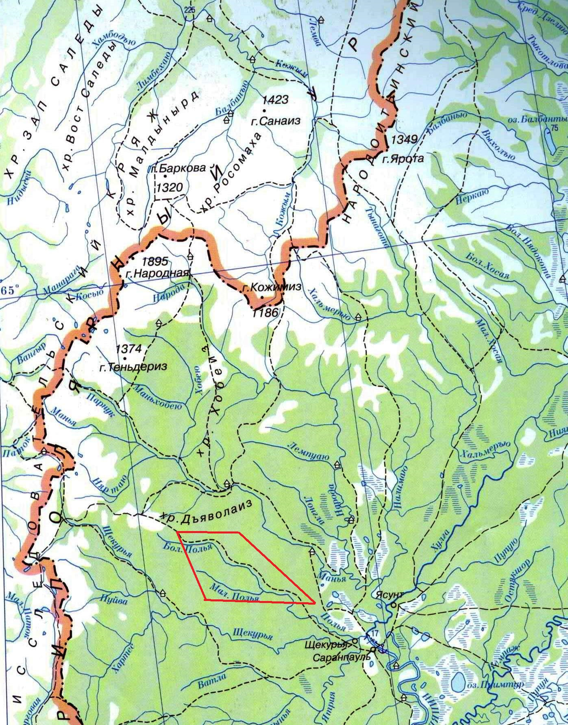

Fig. 1. Geographic location of research area (highlighted with red trapezoid)

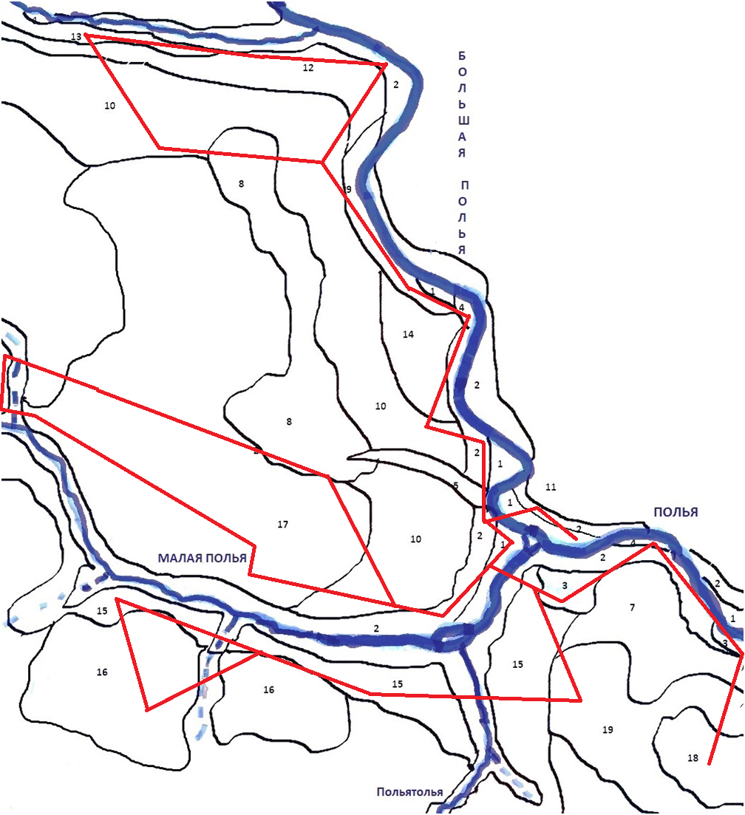

Fig. 2 Landscape structure of the Polia River valley and nearby watershed heights

Legend to the Landscape scheme
With red lines are shown routes of the landscape profiling
Landscapes
Drained | Low mountain | Intermountain basin | Mountain-valley
Tundra- rare taiga |  | 8. Upper large-hillock watershed swamps with sphagnum low-growth spruce | 1. Low floodplain with grasslands.  2. Over-floodplain terrace with moss-shrub-grass spruce trees  3. Dwarf birch thicket -meadow over-floodplain terrace with old-age depressions  4. Low floodplain with pebble beaches  5. Valleys of small watercourses with dwarf birch thicket -meadow vegetation
Taiga | 6. The inclined surface of watershed hills with cedar forest mixed with birch green moss-cranberry-blueberry  7. Slightly inclined surface of the foothills with spruce tree forest with an admixture of birch horsetail-cranberry-green moss  9.Steeply inclined surface with the larch forest ledum-cranberry-green moss with a mixture of cedar and spruce  10.Slightly inclined surface of a hill with mixed horsetail-blueberry-cranberry- green moss forest  11.Hollow convex watershed area with pine forest mixed with cedar ledum-crowberry-blueberry  12. Hollow semi convex surface with cedar birch forest with an admixture of spruce cranberry-blueberry  13. Steeply inclined surface of the valley of the small watercourse with birch larch forest blueberry-cranberry  14.Slightly inclined surface of watershed with the larch forest cranberry-crowberry-white moss  15. Gently inclined small hillock weakly sloping surface of the valley with spruce forest herb-sedge-green moss  16.Steeply inclined surface of the slope and cedar forest mixed with spruce and larch ledum-cranberry-white moss  17.Hollow convex slope surface with cedar forest mixed with birch shrub-green moss  18.Hollow convex slope the surface of the hill with the birch-cedar cranberry-blueberry forest  19. The sloping surface of the hill with shrub-green moss cedar forest

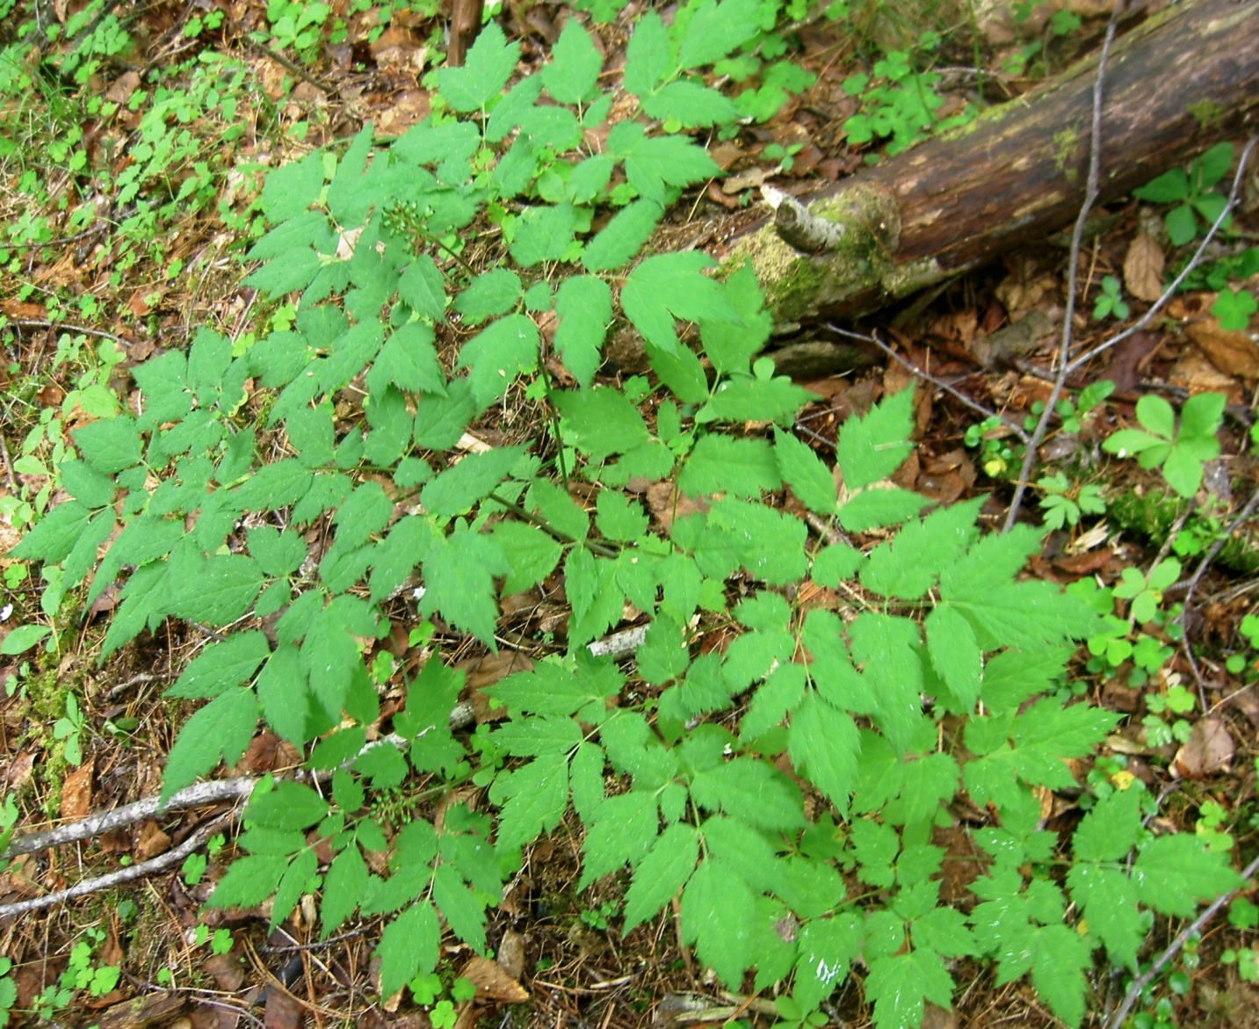

Fig.3 (Actaea spicata)

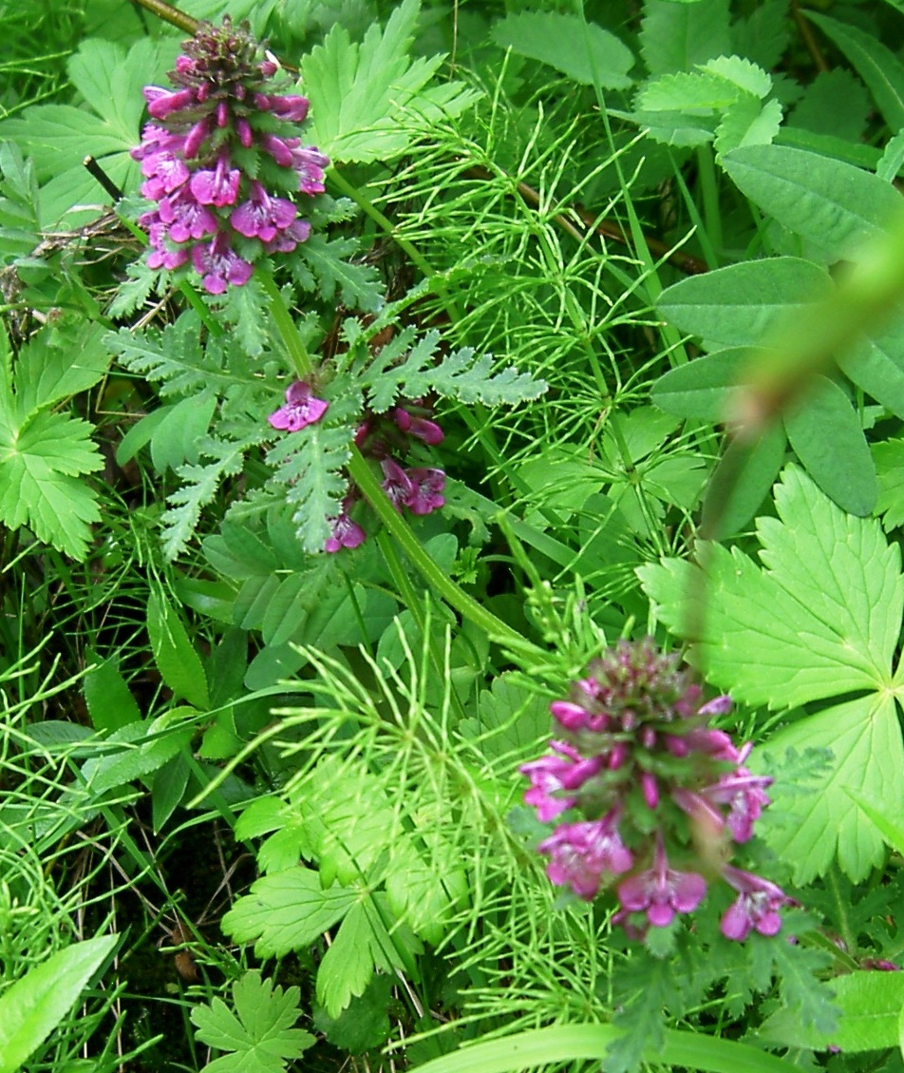

Fig.4 (Pediculáris verticilláta)

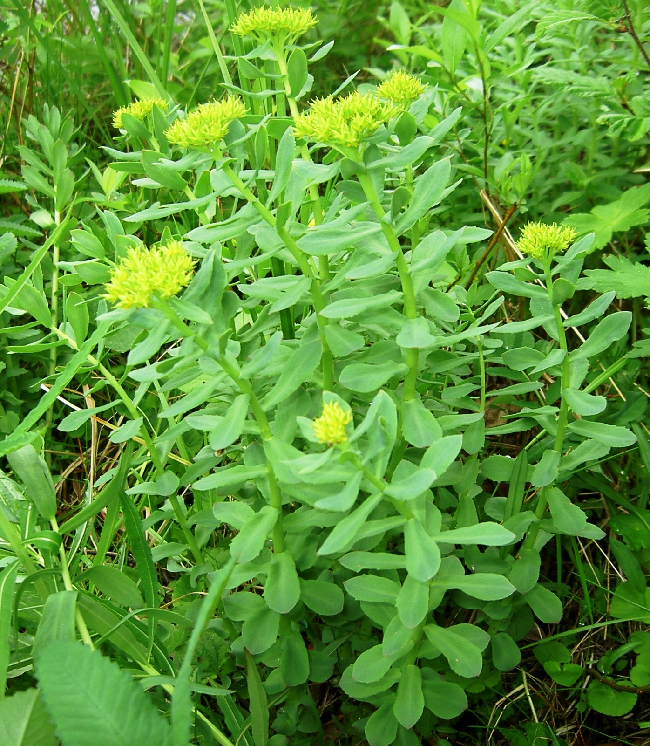

Fig.5 (Rhodíola rósea)

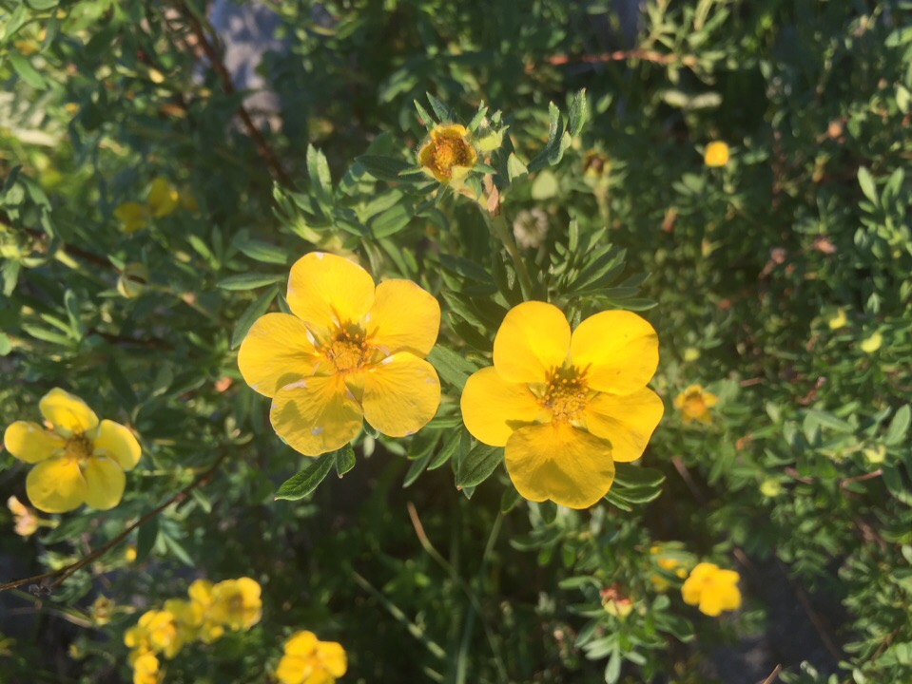

Fig.6 (Pentaphylloides fruticosa)

